The Town of Eliot is regulated for its Separated Stormwater Discharges by a Clean Water Act Permit
────
This Fact Sheet was designed to inform Town Staff and Elected Officials about the Permit

Last Revised
May 2021
Town of Eliot, Maine
Stormwater Awareness Fact Sheet for
Municipal Staff and Officials

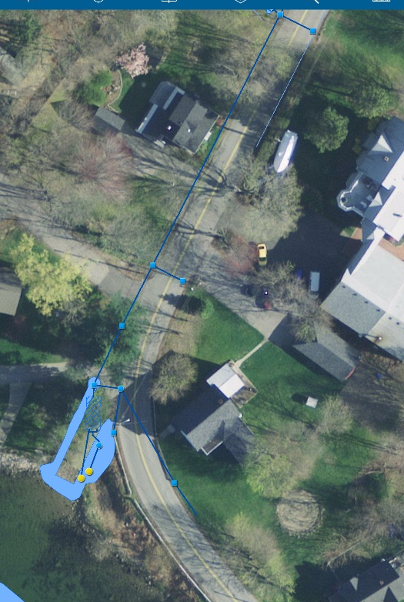
This is a snapshot of the mapping program installed on the IPAD in use by Public Works to inspect stormwater infrastructure in town. The IPAD and program are also used for the sanitary sewer system. The stormwater infrastructure shown is of the Pleasant Street Phase I Infrastructure installed in 2016. A subsurface retention system similar to a leachfield was installed to promote infiltration, which lowers the temperature of runoff during hot weather, and sediments and litter before discharge into the Piscataqua River.

About this Fact Sheet
This fact sheet is being provided to help fulfill a requirement of a Clean Water Act Permit to which the Town is subject. The Permit is called the General Permit for Stormwater Discharges from Municipal Separate Storm Sewer Systems (hereafter referred to as the MS4 General Permit or the Permit). It was first issued by the Maine Department of Environmental Protection in 2003. The DEP issued new permits in 2008, 2013 and 2020.
The permit requirements affect many aspects of municipal operations. Town Staff and Boards must be made aware of this Clean Water Act permit and its requirements to stay in compliance.
A copy of the most recent 5-year Plan showing how the Town complies with the permit requirements is available on the Town’s Public Works webpage for Stormwater.

Why am I receiving this Fact Sheet? One of the requirements of the Permit is that certain staff and elected officials be made aware of the Permit and its requirements. You are receiving this Fact Sheet because some aspect of your job or position with the Town is affected by the MS4 General Permit, therefore, the staff who implement the Permit believe that you should be made aware of the Permit. This fact sheet provides you with an overview of the Permit requirements and identifies how the requirements affect the various staff, elected and appointed officials.
What should I do with the information? Read through this Fact Sheet to gain an understanding of which elements might apply to your position with the Town. The Permit requires that we assess your awareness of the Permit periodically. Town staff or the Town’s consultant may interview you, or attend a meeting to determine if your committee or board is aware of the permit.
General Information you need to know about the MS4 General Permit: The Permit applies to the “Urbanized Area” of the Town, and is designed to reduce the discharge of pollutants from the Town’s regulated, separated storm drain system, to protect water quality, and satisfy appropriate requirements of the Clean Water Act. The attached figure shows the Urbanized Area for the Town of Eliot. Urbanized areas are determined by the US Census Department, based on population density and impervious surface cover. The attached brochure titled, “Follow the Flow”, shows how stormwater can become polluted in urbanized areas and can flow untreated into the storm drain system, which discharges directly into waters such as the Piscataqua River, smaller streams or marsh areas.
The Permit requires that the Town staff complete many different tasks. The following is a listing of a few of them:
- Prepare a Five-Year Stormwater Program Management Plan describing how the Town will implement the Permit (available on the Town Website under the Public Works Department Stormwater page)
- Educate the public about stormwater issues to raise their awareness. The Town teams with four other communities in York County, in a group called the Southern Maine Stormwater Working Group (SMSWG, pronounced, “sim-see-wig”), and with other communities in the state (using the www.thinkbluemaine.org website) to implement many of the public education programs more cost effectively than if the Town had to implement them alone.
- Encourage the public to change their behaviors so that they are more protective of stormwater. For this element, the Town works with SMSWG to focus on more sustainable YardScaping behaviors ( see www.Yardscaping.org for more information) .
- Involve the public in stormwater protection efforts by conducting programs such as stream clean ups, storm drain stenciling, or attendance at workshops.
- Prepare and maintain a map of the storm drain system and use it to conduct inspections of catch basins, outfalls, and ditches to evaluate them for signs of illicit discharges (Illicit discharges are things that do NOT belong in the storm drain system, like sewage, litter, pet waste or oil). The inspections are also used to identify needed maintenance issues. The Town’s storm drain system map is included on the Town’s GIS maps, available on the Town website.
- Whenever illicit discharges are identified, correct them. An Ordinance (Municipal Code of Ordinances Subpart B. Land Use Regulations Chapter 31 Non-Stormwater Discharges) has been prepared for the town which allows the code enforcement officer to issue a notice of violation if necessary to help correct an illicit discharge.
- Conduct inspections at constructions sites for sediment and erosion control issues whenever the site disturbs more than one acre of land.
- Require inspections at sites that are already constructed to ensure stormwater structures such as detention ponds, catch basins, biofilters or drainage swales are being properly maintained by private parties. A Post Construction ordinance (Municipal Code of Ordinances Subpart B. Land Use Regulations Chapter 35 Post-construction Stormwater Management) has been passed to assist planning staff in informing the public about this requirement, and to ensure the stormwater structures are being properly maintained.
- Perform street sweeping, catch basin cleaning, and maintenance of the storm drain system.
- Implement good practices at all municipal operations where stormwater can become polluted (transfer stations and public works garages require full Stormwater Pollution Prevention Plans to be prepared and implemented, other municipal operations such as fire and police stations have a listing of good practices to follow)
- Train municipal employees in good stormwater practices.
- Prepare annual reports documenting all this information, and provide it to the Maine DEP annually.
What specifically do I need to know for my position?
Select Board and Town Manager: Understand for budgeting and staffing purposes that the Town is subject to the MS4 General Permit, which is a Clean Water Act Permit enforced by the Maine Department of Environmental Protection.
Planning Board: Understand that some of the MS4 General Permit requires two ordinances be enforced by the Town (Non-Stormwater Discharge Ordinance, Post-Construction Ordinance). These ordinances cannot be altered without potentially causing a permit violation.
Conservation Commissions: Understand that the Town is subject to the MS4 General Permit, which is designed to reduce the discharge of pollutants from its regulated storm drain system, and to protect water quality.
Code Enforcement and Planning Departments: Understand that CEO Role is to assist in enforcing against illicit discharges, and sediment/erosion control issues. Understand that Planning Department Role is to track construction and Post Construction sites in the Urbanized Area that disturb greater than 1 acre of land, and inform applicants of Ordinance requirements.
Where to go for more information: The Public Works Stormwater page has more information for you. The following people are primarily responsible for implementing the MS4 General Permit in your town, and can be contacted for more information:
Public Works Director or Public Works Assistant
Planner
Code Enforcement Officer
Town Manager
About this Fact Sheet
This fact sheet is being provided to help fulfill a requirement of a Clean Water Act Permit to which the Town is subject. The Permit is called the General Permit for Stormwater Discharges from Municipal Separate Storm Sewer Systems (hereafter referred to as the MS4 General Permit or the Permit). It was issued by the Maine Department of Environmental Protection, and is effective from July 1, 2013 to June 30, 2018. Though the Permit was supposed to expire at the end of June 2018, the DEP extended the Permit until they can issue a new one. The Town Staff and their consultant have been working with other regulated Towns to review and comment on the drafts of the Permit remove costly and unreasonable requirements that would not benefit the environment.

