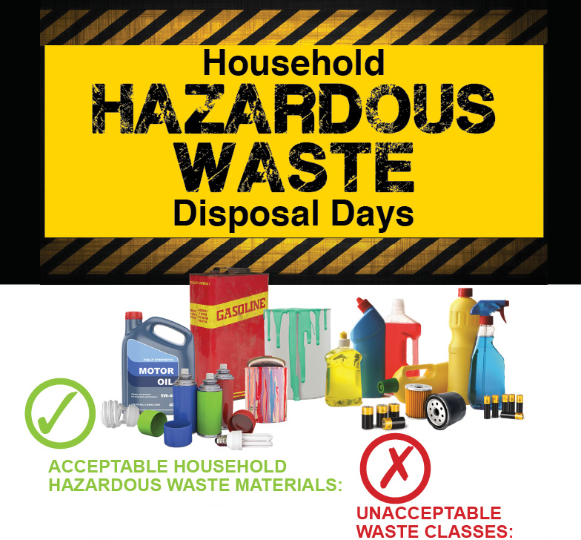

* Asbestos
* Smoke Detectors
* Compressed gas cylinders
* Ammunition, fireworks, explosives
* Prescription medicines/syringes
* Commercial or industrial waste
* Infectious & biological waste
* Radioactive waste
* Fire extinguishers
* Tires
* Fluorescent bulbs
* Latex paint (pop top, let dry, throw away)
* Motor oil & car batteries

From your workbench:

* Adhesives, Glues, resins
* Hobby supplies, artist supplies
* Oil Based paint
* Stains, thinners and strippers
* Solvents & varnishes

From your garage:

* Engine degreasers, brake fluids
* Transmission fluids
* Waste fuels (kerosene, gasoline)

From your yard:

* Insecticides, weed killers, poisons
* Pesticides
* Swimming pool chemicals
* Wood preservatives

From your house:

* Aerosol cans
* Mercury & articles with mercury
* Photo chemicals, chemistry sets
* Mercury added products

**To ensure safety**

* Never mix chemicals
* Never smoke while handling hazardous materials
* Do not place waste in garbage bags
* Tighten caps & lids leaving material in original labeled containors
* Sort and pack paint, pesticides & household cleaners separately
* Pack containers in sturdy upright boxes & pad with newspaper
* Pack your vehicle & go directly to the site
* Never dump these chemicals down the storm drain, your sink or toilet
* You must stay in your vehicle when at the drop off site

**Date: Wednesday, June 17th**

**Time: 1:00pm – 5:00pm**

**Location: Transfer Station**

**Route 236**

**Eliot, Maine**

**Sponsored by: The Town of Eliot**

**Questions call: 207-439-9451**

This event is fee based and open to all residents of the Town of Eliot. Must bring proof of residency, such as driver’s license.

The Town of Eliot will be holding HHWD’s quarterly in the months of Sept. and June. Times will vary slightly due to seasonal time changes. Updates on Town Webiste,eliotme.org Sign up for updates

